PROJECT DOCUMENTATION
PRESENTED BY : ROHIT KOTARE
1. TITLE: Fake News Detection & Verification Tool

2. PROJECT STATEMENT : The Fake News Detection & Verification Tool is designed to identify and verify misleading or false news articles using data analysis and machine learning techniques. The system analyzes news content, checks credibility, and helps users distinguish between real and fake information to reduce the spread of misinformation.

3. OUTCOMES :
- Detects and classifies fake and real news effectively.
- Provides quick and reliable news verification.
- Reduces misinformation spread through automated analysis.
- Improves digital literacy and awareness among users.
- Supports future scalability and feature expansion.

4. Modules to Be Implemented
1. User Authentication & Profile Management
- Registration and login system using JWT authentication.
- User profiles to manage submitted articles and analysis history.
2. News Article & Social Media Post Ingestion Module
- Paste or upload text, or fetch content from a URL/social media link.
- Text extraction and cleaning (handling hashtags, emojis, metadata).
3. NLP Preprocessing & Feature Extraction Module
- Tokenization, stopword removal, and lemmatization using NLTK/spaCy.
- Named Entity Recognition (NER) to identify people, places, and organizations.
4. Fake News Classification Module
- Transformer-based models (e.g., BERT, RoBERTa) fine-tuned on fake news datasets.
- Output: Probability score (0–1) and classification (real/suspicious/fake).
5. Claim Verification Module
- Extract factual claims using dependency parsing and NER.
- Verify claims against trusted fact-checking APIs and databases.
6. Explainability & Visualization Module
- Highlight suspicious phrases in the text.
- Display verification results with supporting source links.
7. Admin Dashboard
- Manage trusted source lists and API keys.
- Monitor system performance and usage statistics.

5. ARCHITECTURE DIAGRAM
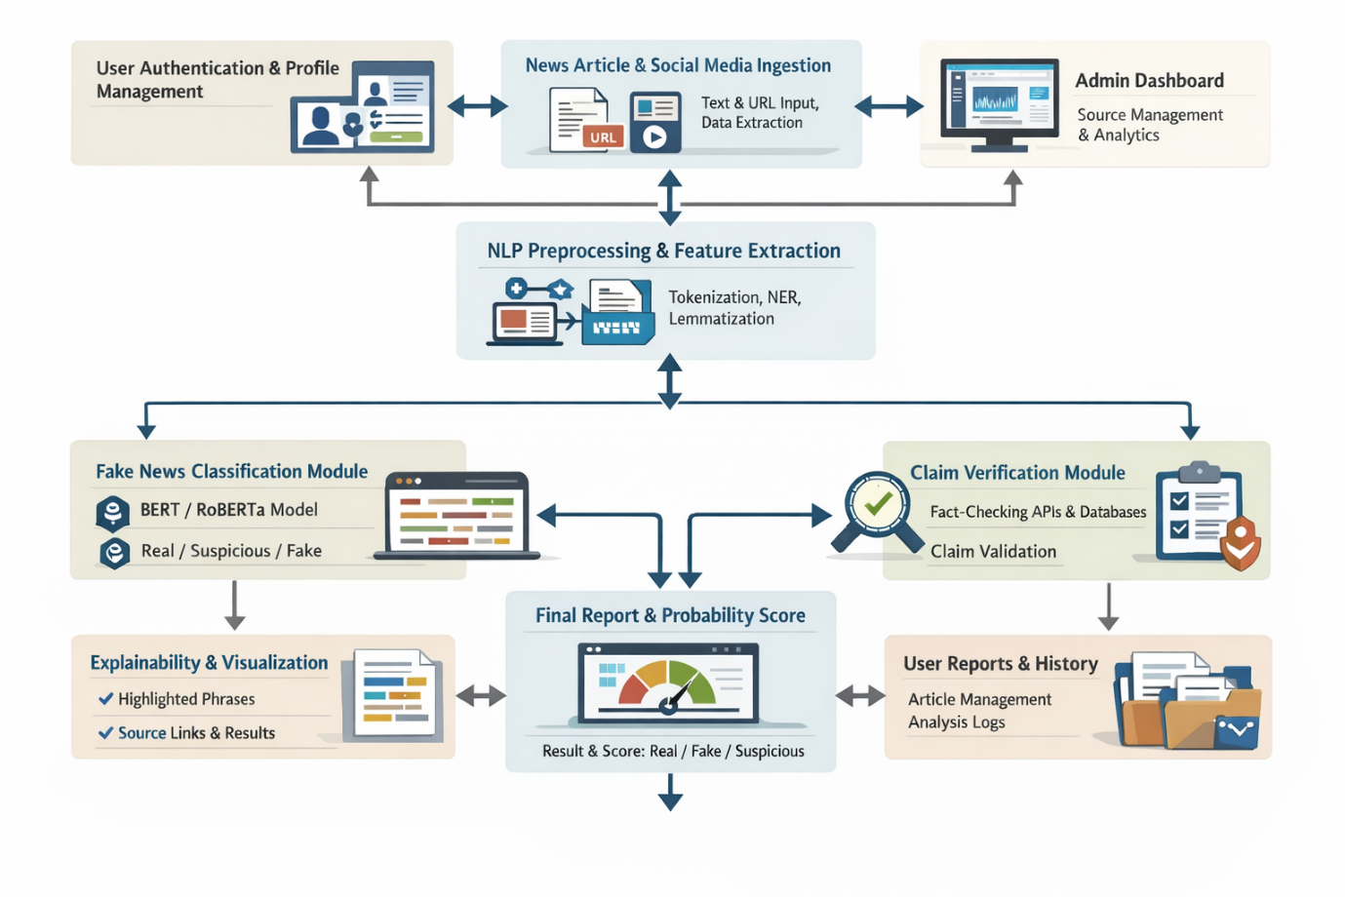

6. DATABASE SCHEMA
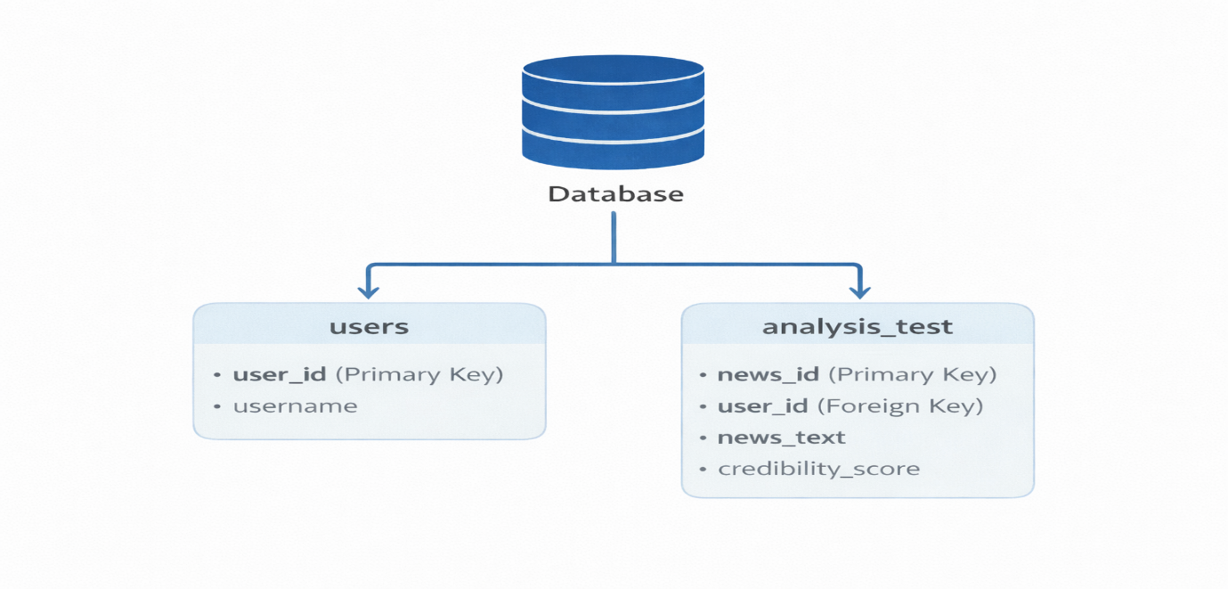

7. CONCLUSION
The Fake News Detection & Verification Tool provides an end-to-end AI-driven solution to identify, analyze, and verify misinformation in real time. By combining NLP, deep learning, and trusted fact-checking sources, the system enhances information credibility, promotes digital literacy, and supports responsible content consumption. This project not only delivers a practical tool but also offers hands-on experience with modern AI technologies for large-scale, real-world problems.

8. SAMPLE OUTPUTS




